Data Science from scratch

Contents

I. Fundamentals 2

1. Matrices & Linear Algebra Fundamentals 3

2. Hash Functions, Binary Trees 3

3. Relational Algebra and DB basics 3

4. Inner, Outer, Cross and Theta Join. 3

5. CAP Theorem 3

6. Sharding 3

7. OLAP 3

8. Multidimensional Data Model 3

9. ETL 3

10. JSON & XML 3

11. NoSQL 3

12. Regex (Regular Expressions) 3

13. Virtual Environments Setup (ISN’T COMPLETED) 3

II. Programming (Python and R) 3

1. Install Packages 3

2. Factor Analysis 3

3. Functions 3

4. Read Data. 3

5. Manipulate Data Frames 3

6. Subsetting Data Frames 3

III. Statistics (and how to calculate them in Python) 3

1. Descriptive Statistics 3

2. Histograms 3

3. Percentiles and Outliers 3

4. Probability Theory 3

5. Bayes Theorem 3

6. Random Variables 3

7. Probability Distribution Function 3

8. Cumulative Distribution Function 3

9. Central Limit Theorem 3

10. Continuous Distributions 3

11. Skewness 3

12. Monte Carlo Method 3

13. Hypothesis Testing 3

14. Normality Tests 3

15. Correlation Tests 3

16. Stationary Tests 3

17. Parametric Statistical Hypothesis Tests 3

18. Nonparametric Statistical Hypothesis Tests 3

19. Analysis of Variance (ANOVA) 3

20. Estimation 3

21. Confidence intervals 3

22. Maximum Likelihood Estimation (MLE) 3

23. Kernel Density Estimate 3

24. Regression 3

25. Covariance and Correlation 3

26. Causation 3

27. Distance Measures 3

IV. Machine Learning 3

# Fundamentals

## Matrices & Linear Algebra Fundamentals

Linear algebra topics:

* Vectors
* Matrices
* Transpose of a matrix
* Inverse of a matrix
* Determinant of a matrix
* Trace of a matrix
* Covariance Matrix
* Dot product
* Eigenvalues
* Eigenvectors

## Hash Functions, Binary Trees

Hashing is a technique that is used to uniquely identify a specific object from a group of similar objects. Some examples of how hashing is used in our lives include:

* In universities, each student is assigned a unique roll number that can be used to retrieve information about them.
* Diagram

  Description automatically generatedIn libraries, each book is assigned a unique number that can be used to determine information about the book, such as its exact position in the library or the users it has been issued to etc.

In both these examples the students and books were hashed to a unique number.

With binary trees you can do a lot of operations like transversals, summations, construction, conversions, etc.

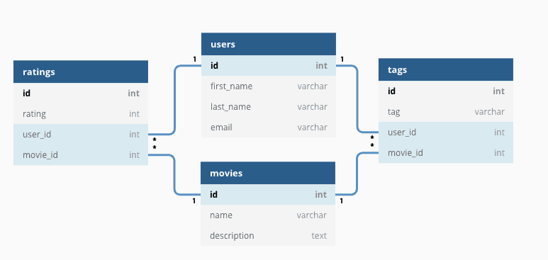

## Relational Algebra and DB basics

 Relational algebra query operations are performed recursively on a relation. The output of these operations is a new relation, which might be formed from one or more input relations.

The relational databases are tabular data that are interrelated.

## What is cross join SQL and When to use cross join SQL?Inner, Outer, Cross and Theta Join.

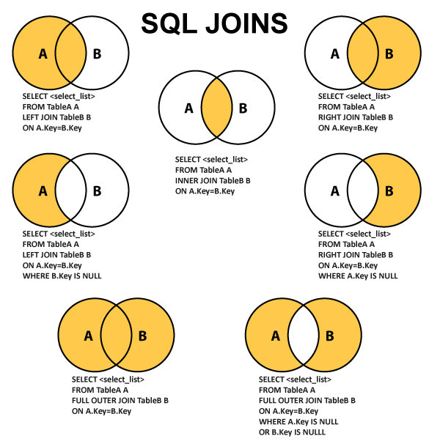

## CAP Theorem

* Consistency
* Availability
* Partition Tolerance

There’s a trade off between consistency and availability when the system has partitions. Partitioning is when the system can’t communicate each part with each other. If the system never has partitions, you can make the system consistent and available.

In real world you have degrees of consistency and degrees of availability and make trade offs between those two.

## Sharding

Sharding is when you have an enormous amount of data and you want to access them in the fastest way. This process is by fragmentating the data into small pieces and storing them in different servers to speed up the performance.

One way to access to every piece is by hierarchical sharding. Which means that you cut your piece into another small pieces and so on.

NoSQL uses sharding internally.

## OLAP

OLAP enables fast, flexible multidimensional data analysis for business intelligence (BI) and decision support applications.

OLAP (for online analytical processing) is software for performing multidimensional analysis at high speeds on large volumes of data from a data warehouse, data mart, or some other unified, centralized data store.

In theory, a cube can contain an infinite number of layers. (An OLAP cube representing more than three dimensions is sometimes called a hypercube.) And smaller cubes can exist within layers—for example, each store layer could contain cubes arranging sales by salesperson and product. In practice, data analysts will create OLAP cubes containing just the layers they need, for optimal analysis and performance.

**OLAP cubes enable four basic types of multidimensional data analysis:**

**Drill-down**

The drill-down operation converts less-detailed data into more-detailed data through one of two methods—moving down in the concept hierarchy or adding a new dimension to the cube. For example, if you view sales data for an organization’s calendar or fiscal quarter, you can drill-down to see sales for each month, **moving down in the concept hierarchy of the “time” dimension.**

**Roll up**

**Roll up is the opposite of the drill-down function**—it aggregates data on an OLAP cube by moving up in the concept hierarchy or by reducing the number of dimensions. For example, you could move up in the concept hierarchy of the “location” dimension by viewing each country's data, rather than each city.

**Slice and dice**

The slice operation **creates a sub-cube by selecting a single dimension from the main OLAP cube**. For example, you can perform a slice by highlighting all data for the organization's first fiscal or calendar quarter (time dimension).

The dice operation isolates a **sub-cube by selecting several dimensions within the main OLAP cube**. For example, you could perform a dice operation by highlighting all data by an organization’s calendar or fiscal quarters (time dimension) and within the U.S. and Canada (location dimension).

**Pivot**

**The pivot function rotates the current cube view to display a new representation of the data—enabling dynamic multidimensional views of data.** The OLAP pivot function is comparable to the pivot table feature in spreadsheet software, such as Microsoft Excel, but while pivot tables in Excel can be challenging, OLAP pivots are relatively easier to use (less expertise is required) and have a faster response time and query performance.

## Multidimensional Data Model

The multi-Dimensional Data Model is a method which is used for ordering data in the database along with good arrangement and assembling of the contents in the database.

The Multi-Dimensional Data Model allows customers to interrogate analytical questions associated with market or business trends, unlike relational databases which allow customers to access data in the form of queries. They allow users to rapidly receive answers to the requests which they made by creating and examining the data comparatively fast.

**OLAP (online analytical processing) and data warehousing uses multi-dimensional databases.** It is used to show multiple dimensions of the data to users.

It represents data in the form of data cubes. Data cubes allow to model and view the data from many dimensions and perspectives. It is defined by dimensions and facts and is represented by a fact table. Facts are numerical measures and fact tables contain measures of the related dimensional tables or names of the facts.

The following stages should be followed by every project for building a Multi-Dimensional Data Model:

**Stage 1: Assembling data from the client:** In first stage, a Multi-Dimensional Data Model collects correct data from the client. Mostly, software professionals provide simplicity to the client about the range of data which can be gained with the selected technology and collect the complete data in detail.

**Stage 2: Grouping different segments of the system:**In the second stage, the Multi-Dimensional Data Model recognizes and classifies all the data to the respective section they belong to and builds it problem-free to apply step by step.

**Stage 3: Noticing the different proportions:** In the third stage, it is the basis on which the design of the system is based. In this stage, the main factors are recognized according to the user’s point of view. These factors are also known as “Dimensions”.

**Stage 4: Preparing the actual-time factors and their respective qualities:** In the fourth stage, the factors which are recognized in the previous step are used further for identifying the related qualities. These qualities are also known as **“attributes”** in the database.

**Stage 5: Finding the actuality of factors which are listed previously and their qualities:**In the fifth stage,A Multi-Dimensional Data Model separates and differentiates the actuality from the factors which are collected by it. These play a significant role in the arrangement of a Multi-Dimensional Data Model.

Stage 6: Building the Schema to place the data, with respect to the information collected from the steps above: In the sixth stage, on the basis of the data, which was collected previously, a Schema is built. M

**Advantages of Multi-Dimensional Data Model**

* It is easy to maintain.
* Its performance is better than that of normal databases (e.g. relational databases).
* The representation of data is better than traditional databases. That is because the multi-dimensional databases are multi-viewed and carry different types of factors.
* It is workable on complex systems and applications, contrary to the simple one-dimensional database systems.
* The compatibility in this type of database is an upliftment for projects having lower bandwidth for maintenance staff.

**Disadvantages of Multi-Dimensional Data Model**

* The multi-dimensional Data Model is slightly complicated in nature, and it requires professionals to recognize and examine the data in the database.
* During the work of a Multi-Dimensional Data Model, when the system caches, there is a great effect on the working of the system.
* It is complicated in nature due to which the databases are generally dynamic in design.
* The path to achieving the end product is complicated most of the time.
* As the Multi-Dimensional Data Model has complicated systems, databases have many databases due to which the system is very insecure when there is a security break.

## ETL

ETL is a type of data integration that refers to the three steps (extract, transform, load) used to blend data from multiple sources. **It's often used to build a data warehouse**. During this process, data is taken (extracted) from a source system, converted (transformed) into a format that can be analyzed, and stored (loaded) into a data warehouse or other system. Extract, load, transform (ELT) is an alternate but related approach designed to push processing down to the database for improved performance.

## JSON & XML

JSON:

* Stands for **J**ava**S**cript **O**bject **N**otation
* Is a lightweight format for storing and transporting data
* Is often used when data is sent from a server to a web page
* Is "self-describing" and easy to understand

JSON example:

XML:

* stands for eXtensible Markup Language
* Is a markup language much like HTML
* Was designed to store and transport data
* Graphical user interface, text, application

  Description automatically generatedWas designed to be self-descriptive

XML Example: is displayed as 🡪

## NoSQL

NoSQL databases are purpose built for specific data models and have flexible schemas for building modern applications. NoSQL databases are widely recognized for their ease of development, functionality, and performance at scale. These types of databases are optimized specifically for applications that require large data volume, low latency, and flexible data models, which are achieved by relaxing some of the data consistency restrictions of other databases.

In a NoSQL database, a book record is usually stored as a JSON document. For each book, the item, ISBN, Book Title, Edition Number, Author Name, and AuthorID are stored as attributes in a single document. In this model, data is optimized for intuitive development and horizontal scalability.

NoSQL databases are a great fit for many modern applications such as mobile, web, and gaming that require flexible, scalable, high-performance, and highly functional databases to provide great user experiences.

* Flexibility: NoSQL databases generally provide flexible schemas that enable faster and more iterative development. The flexible data model makes **NoSQL databases ideal for semi-structured and unstructured data.**
* Scalability: NoSQL databases are generally designed to scale out by using distributed clusters of hardware instead of scaling up by adding expensive and robust servers. Some cloud providers handle these operations behind-the-scenes as a fully managed service.
* High-performance: NoSQL database are optimized for specific data models and access patterns that enable higher performance than trying to accomplish similar functionality with relational databases.
* Highly functional: NoSQL databases provide highly functional APIs and data types that are purpose built for each of their respective data models.

## Regex (Regular Expressions)

/d: digits /:D non-digits UPPERCASE [A-Z[ lowercase [a-z[ numbers [0-9[

Combinations

* Upper, lower and numbers = [a-zA-Z0-9[
* Upper and lower=[a-zA-Z[

Python example of regular expressions There’s a lot of regular expressions to study!!!!!!!!!!!!!!!!!!!!!!!!

## Virtual Environments Setup (ISN’T COMPLETED)

First thing you need to do is execute the [venv](https://docs.python.org/3/library/venv.html) module, which is part of the Python standard library.

The only thing left to do is to “activate” our environment by running the following scripts



# Programming (Python and R)

## Install Packages

To Install packages in Python you need to open de Windows Terminal or Windows PowerShell and write the followings command: pip install *package name or* py -m pip install *package name*

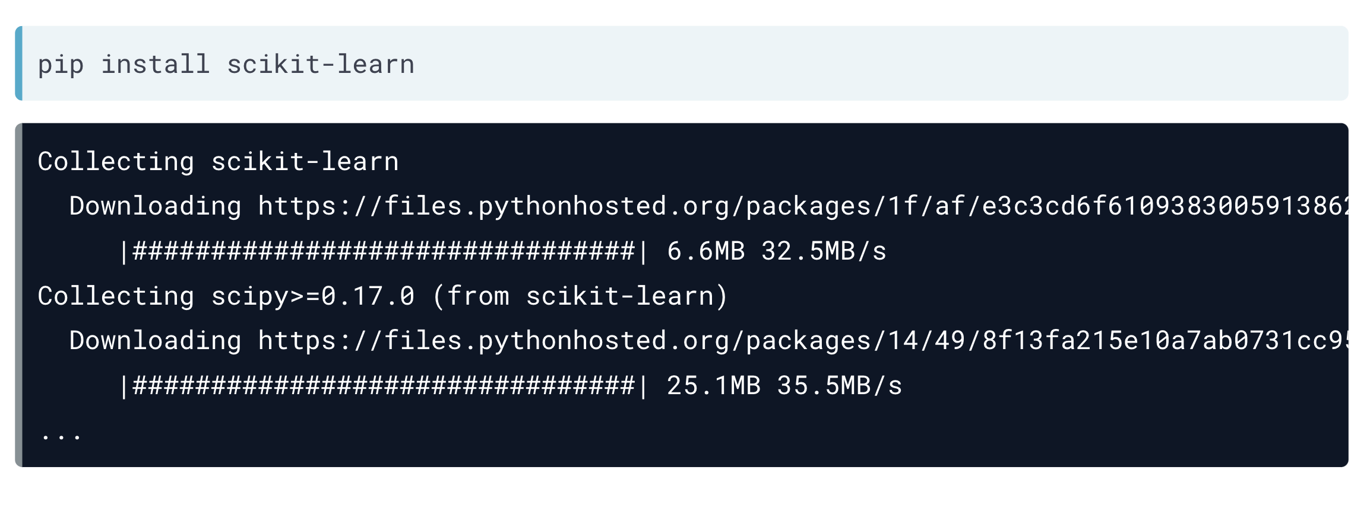

To use packages in Rstudio you must activate them in the Packages window

And if the packages aren’t in that window, you have to open Tools 🡪 Install Packages and write the package name

## Factor Analysis

Factor analysis is a technique that is used to reduce a large number of variables into fewer numbers of factors. This technique extracts maximum common variance from all variables and puts them into a common score. As an index of all variables, we can use this score for further analysis. Factor analysis is part of general linear model (GLM) and this method also assumes several assumptions**: there is linear relationship, there is no multicollinearity, it includes relevant variables into analysis, and there is true correlation between variables and factors.** Several methods are available, but principal component analysis (PCA) is used the most.

Assumptions:

**No outlier:** Assume that there are no outliers in data.

**Adequate sample size**: The case must be greater than the factor.

**No perfect multicollinearity:** Factor analysis is an interdependency technique. There should not be perfect multicollinearity between the variables.

**Homoscedasticity:** Since factor analysis is a linear function of measured variables, it does not require homoscedasticity between the variables.

**Linearity:** Factor analysis is also based on linearity assumption. Non-linear variables can also be used. After transfer, however, it changes into linear variable.

**Interval Data**: Interval data are assumed.

There are different types of methods used to extract the factor from the data set:

1. **Principal component analysis**: This is the most common method used by researchers. PCA starts extracting the maximum variance and puts them into the first factor. After that, it removes that variance explained by the first factors and then starts extracting maximum variance for the second factor. This process goes to the last factor.

2. **Common factor analysis**: The second most preferred method by researchers, it extracts the common variance and puts them into factors. This method does not include the unique variance of all variables. This method is used in SEM.

3. **Image factoring**: This method is based on correlation matrix. OLS Regression method is used to predict the factor in image factoring.

4. **Maximum likelihood method**: This method also works on correlation metric, but it uses maximum likelihood method to factor.

5. **Other methods of factor analysis**: Alfa factoring outweighs least squares. Weight square is another regression-based method which is used for factoring.

## Functions

An R function is created by using the keyword **function**. The basic syntax of an R function definition is as follows:

We can create user-defined functions in R. They are specific to what a user wants and once created they can be used like the built-in functions. Below is an example of how a function is created and used.

🡪

In Python functions work the same as in R, but have a different code

 🡪

If you do not know how many arguments that will be passed into your function, add a * before the parameter name in the function definition. In the following example the functions will print out the length of the list that will be created by iterating each value passed to the function

🡪 2

If you do not know how many keyword arguments that will be passed into your function, add two asterisk: ** before the parameter name in the function definition.

🡪 His last name is Refsnes

Also, If we call the function without argument, it uses the default value:

## Read Data.

In Python to read data for data science you’ll use the pandas package as pd and call each function for each data type.

Each function has its own arguments, but I’ll show you only the most used ones.

In Rstudio its much easier to read data. Just click the import dataset option and select your data type

And if you’re working with CSV files you need to call them following code: *read.csv(“data.csv”)*

## Manipulate Data Frames

In this chapter I’m going to introduce you to pandas functions to manipulate data frames in python

🡪

🡪

And now I’m going to show you some R code to manipulate data frames

This code shows us the data type for each column 🡪

Data types 🡪



## Subsetting Data Frames

In this chapter I will show you only how to slice your data in R

Now the code to subset data in Python

# Statistics (and how to calculate them in Python)

For this chapter we are going to work with the same dataset to perform all the statistics in python.

## Descriptive Statistics

The descriptive statistics are a group of different metrics that we can extract from a data set.

* Mean: Average value
* Median: Midpoint between the highest and the lowest values
* Rango: Span of values over which your data occurs
* Standard Deviation of the Mean (σ): On average, how much each measurement deviates from the mean
* Variance ($σ^{2}$): Is a measure of how spread out a data set is. It is calculated as the average squared deviation of each number from the mean of a data set

In just one line of code, we have the number of values, mean, standard deviation, minimum value, maximum value, the values positioned in 25%, 50% (median) and 75%. For each column.

A small standard deviation can be a goal in certain situations where the results are restricted, for example, in product manufacturing and quality control. A particular type of car part that has to be 2 centimeters in diameter to fit properly had better not have a very big standard deviation during the manufacturing process! A big standard deviation in this case would mean that lots of parts end up in the trash because they don’t fit right; either that, or the cars will have major problems down the road. So the more spread out the group of numbers are, the higher the standard deviation.

But in situations where you just observe and record data, **a large standard deviation isn’t necessarily a bad thing**; it just reflects a large amount of variation in the group that is being studied.

For example, if you look at salaries for everyone in a certain company, including everyone from the student intern to the CEO, the standard deviation may be very large. On the other hand, if you narrow the group down by looking only at the student interns, the standard deviation is smaller, because the individuals within this group have salaries that are similar and less variable. The second data set isn’t better, it’s just less variable.

Similar to the mean, **outliers affect the standard deviation** (after all, the formula for standard deviation includes the mean). Here’s an example: the salaries of the L.A. Lakers in the 2009–2010 season range from the highest, $23,034,375 (Kobe Bryant) down to $959,111 (Didier Ilunga-Mbenga and Josh Powell). Lots of variation, to be sure!

The standard deviation of the salaries for this team turns out to be $6,567,405; it’s almost as large as the average. However, as you may guess, if you remove Kobe Bryant’s salary from the data set, the standard deviation decreases because the remaining salaries are more concentrated around the mean. The standard deviation becomes $4,671,508

*The standard deviation has the same units of measure as the original data. If you’re talking about inches, the standard deviation will be in inches*.

Variance is the square of the standard deviation and is the last metric:

The more spread out the values are in a dataset, the higher the variance. Therefore, the variance gives more importance to outliers than the standard deviation.

## Histograms

All histograms have the same components but because they have different values they differ from each other’s shape.

* Range
  + How widely dispersed are the frequencies of each bin? Extremely large frequency ranges (particularly as a percentage) may indicate data that is fundamentally unreliable.
  + How wide are the bins themselves? Specifically, how broad are the intervals or how descriptive are the classes? Unusually large or small intervals, or unusually broad or narrow categories may indicate important observations about the data as a whole.
* Frequency Density
  + Frequency is measured by the area of the bar. What that means it that you can use a histogram with different interval or class widths to represent data with varying densities.
* Shape
  + The shape of a histogram can lead to valuable conclusions about the trend(s) of the data

As you can see in the code (🡪), we obtained the histogram for the CrimeRate and Education columns. The shape of the data isn’t a bell because they have some outliers.

We can say that the crime rates between 80 and 120 have more frequency than the others. And Education has more values between 12 and 13 .

Other types of histograms:

* Chart, histogram

  Description automatically generatedBell-shaped: A histogram with a prominent ‘mound’ in the center and similar tapering to the left and right. One indication of this shape is that the data is unimodal – meaning that the data has a single mode, identified by the ‘peak’ of the curve. **If the shape is symmetrical, then the mean, median, and mode are all the same value**. Note that a normally distributed data set creates a symmetric histogram that looks like a bell, leading to the common term for a normal distribution: a bell curve
* Right or Left Skewed: A skewed histogram has a peak that is left (or right) of center and a more gradual tapering to the other side of the graph. This is a unimodal data set, with the mode closer to the left (or right) of the graph and smaller than either the mean or the median. The mean of right-skewed data will be located to the right side of the graph and will be a greater value than either the median or the mode. This shape indicates that there are a number of data points, perhaps outliers, that are greater than the mode for the left skewed and lesser than the mode for the right

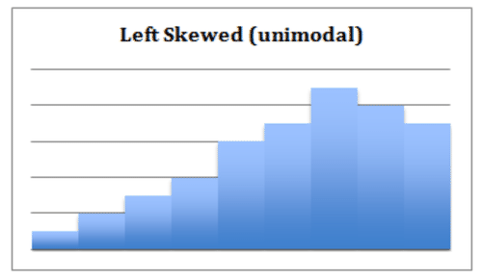

* Undefined Bimodal: This shape is not specifically defined, but we can note regardless that it is bimodal, having two separated classes or intervals equally representing the maximum frequency of the distribution.

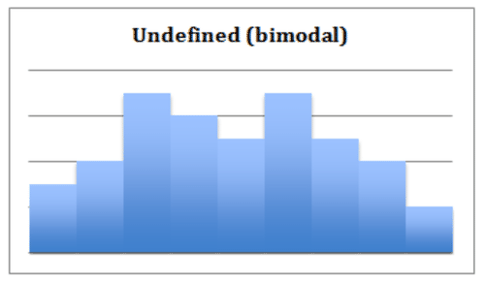

## Percentiles and Outliers

Percentiles is in everyday use, but there is no universal definition for it. The most common definition of a percentile is a number where a certain percentage of scores fall below that a number.

An outlier is an observation that lies an abnormal distance from other values in a random sample.

One way to visualize the percentiles rank and the outliers is by plotting a boxplot.

The box limits the 25th and 75th percentiles. The two lines outside the box limit the 10th and 90th percentile and the circles in red show the outliers.

## Probability Theory

The probability theory is a branch of mathematics concerned with the analysis of random phenomena. The outcome of a random event cannot be determined before it occurs, but it may be any one of several possible outcomes. The actual outcome is considered to be determined by chance. This theory has great importance for data science. One needs to possess a comprehensive understanding of the probability theory to be a well-performing data scientist. For instance, probability distributions play a key role in predictive analytics.

**Conditional Probability**

We defined the conditional probability as the probability of event A given that event B has occurred, is denoted as p(A|B).

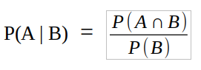*“Conditional probability is the likelihood of an event A to occur given that another event that has a relation with event A has already occurred.”*

The formula of the conditional probability:

P(A ∩ B) is the probability that both events A and B occur. P(B) is the probability that event B occurs. The conditional probability is typically not commutative which means that P(A | B) is not equal to P(B | A).

In the following example we see a probability space (Ω) which indicates all the probabilities add up to 1.

Conditional probability is a fundamental concept in probability theory and statistics. For instance, Bayesian statistics arises from an interpretation of the conditional probability.

A given condition might not have any effect on an event so the conditional and unconditional probabilities are equal (i.e. P( A | B) = P(A)). In such cases, the events **A and B are said to be independent.**

**Joint Probability**

Joint probability is the probability of two events occurring together. If two events are independent, the joint probability is calculated by multiplying the probabilities of each event.

**P(A ∩ B) = P(A) * P(B)** If we put that in the equation of the conditional probability:

Joint and conditional probability example:

The following table shows the number of female and male students enrolled in the sociology and music classes.

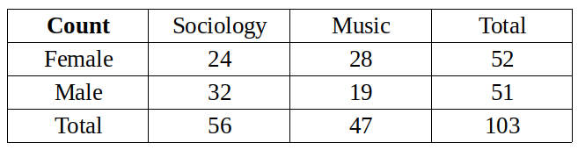

There are 103 students. We will first calculate the unconditional probabilities.

P(Female) = 52 / 103 = 0.505

P(Male) = 51 / 103 = 0.495

P(Music) = 47 / 103 = 0.456

P(Sociology) = 56 / 103 = 0.544

The joint probabilities can be calculated by dividing the number in a cell by the total number of students. For instance, the probability that a student is female and enrolled in the sociology class:

***~~P(Female ∩ Sociology) = (P(Female) * P(Sociology)) =24 / 103 = 0.233~~***

We can calculate the other joint probabilities similarly. The following table contains all the probabilities for these events.

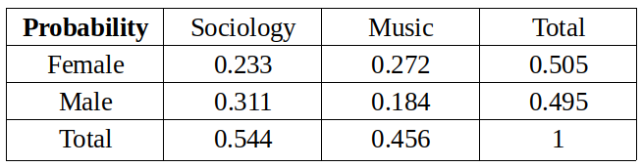

We will calculate the conditional probabilities now.

What is the probability that a student is female given that the student is enrolled in the music class?

P(Female | Music) = P(Female ∩ Music) / P(Music) = 0.272 / 0.456 = 0.596

What is the probability that a student is male given that the student is enrolled in the sociology class?

P(Male | Sociology) = P(Male ∩ Sociology) / P(Sociology) = 0.311 / 0.544 = 0.572

## Bayes Theorem

Principled way of calculating a conditional probability without the joint probability.

Specifically, one conditional probability can be calculated using the other conditional probability; for example:

*Firstly, in general, the result P(A|B) is referred to as the posterior probability and P(A) is referred to as the prior probability and sometimes P(B|A) is referred to as the likelihood and P(B) is referred to as the evidence.*

P(A|B) = P(B|A) * P(A) / P(B)

The reverse is also true; for example:

P(B|A) = P(A|B) * P(B) / P(A)

It is often the case that we do not have access to the denominator directly, e.g. P(B).

We can calculate it an alternative way; for example:

P(B) = P(B|A) * P(A) + P(B|not A) * P(not A)

This gives a formulation of Bayes Theorem that we can use that uses the alternate calculation of P(B), described below::

P(A|B) = P(B|A) * P(A) / (P(B|A) * P(A) + P(B|not A) * P(not A))

**Diagnostic Test Scenario**

Consider a human population that may or may not have cancer (Cancer is True or False) and a medical test that returns positive or negative for detecting cancer (Test is Positive or Negative), e.g. like a mammogram for detecting breast cancer.

Problem: If a randomly selected patient has the test and it comes back positive, what is the probability that the patient has cancer?

**Manual Calculation**

Medical diagnostic tests are not perfect; they have error.

Sometimes a patient will have cancer, but the test will not detect it. This capability of the test to detect cancer is referred to as the sensitivity, or the true positive rate.

In this case, we will contrive a sensitivity value for the test. The test is good, but not great, with a true positive rate or sensitivity of 85%. That is, of all the people who have cancer and are tested, 85% of them will get a positive result from the test.

P(Test=Positive | Cancer=True) = 0.85

Given this information, our intuition would suggest that there is an 85% probability that the patient has cancer.

Our intuitions of probability are wrong.

This type of error in interpreting probabilities is so common that it has its own name; it is referred to as the **base rate fallacy**.

It has this name because the error in estimating the probability of an event is caused by ignoring the base rate. That is, it **ignores the probability of a randomly selected person having cancer,** regardless of the results of a diagnostic test.

In this case, we can assume the probability of breast cancer is low and use a contrived base rate value of one person in 5,000, or (0.0002) 0.02%.

P(Cancer=True) = 0.02%.

We can correctly calculate the probability of a patient having cancer given a positive test result using Bayes Theorem.

Let’s map our scenario onto the equation:

**P(A|B) = P(B|A) * P(A) / P(B)**

**P(Cancer=True | Test=Positive) = P(Test=Positive|Cancer=True) * P(Cancer=True) / P(Test=Positive)**

We know the probability of the test being positive given that the patient has cancer is 85%, and we know the base rate or the prior probability of a given patient having cancer is 0.02%; we can plug these values in:

P(Cancer=True | Test=Positive) = 0.85 * 0.0002 / P(Test=Positive)

We don’t know P(Test=Positive), it’s not given directly.

Instead, we can estimate it using:

P(B) = P(B|A) * P(A) + P(B|not A) * P(not A)

P(Test=Positive) = P(Test=Positive|Cancer=True) * P(Cancer=True) + P(Test=Positive|Cancer=False) * P(Cancer=False)

Firstly, we can calculate P(Cancer=False) as the complement of P(Cancer=True), which we already know

P(Cancer=False) = 1 – P(Cancer=True)

= 1 – 0.0002

= 0.9998

We can plug in our known values as follows:

P(Test=Positive) = 0.85 * 0.0002 + P(Test=Positive|Cancer=False) * 0.9998

We still do not know the probability of a positive test result given no cancer.

This requires additional information.

Specifically, we need to know how good the test is at correctly identifying people that do not have cancer. That is, testing negative result (Test=Negative) when the patient does not have cancer (Cancer=False), called the true negative rate or the specificity.

We will use a contrived specificity value of 95%.

P(Test=Negative | Cancer=False) = 0.95

With this final piece of information, we can calculate the false positive or false alarm rate as the complement of the true negative rate.

P(Test=Positive|Cancer=False) = 1 – P(Test=Negative | Cancer=False)

= 1 – 0.95

= 0.05

We can plug this false alarm rate into our calculation of P(Test=Positive) as follows:

P(Test=Positive) = 0.85 * 0.0002 + 0.05 * 0.9998

P(Test=Positive) = 0.00017 + 0.04999

P(Test=Positive) = 0.05016

Excellent, so the probability of the test returning a positive result, regardless of whether the person has cancer or not is about 5%.

We now have enough information to calculate Bayes Theorem and estimate the probability of a randomly selected person having cancer if they get a positive test result.

P(Cancer=True | Test=Positive) = P(Test=Positive|Cancer=True) * P(Cancer=True) / P(Test=Positive)

P(Cancer=True | Test=Positive) = 0.85 * 0.0002 / 0.05016

P(Cancer=True | Test=Positive) = 0.00017 / 0.05016

**P(Cancer=True | Test=Positive) = 0.003389154704944**

The calculation suggests that if the patient is informed they have cancer with this test, then there is only 0.33% chance that they have cancer.

And we code all of this in a few lines of code, as it follows:

## Random Variables

A random variable, usually written X, is a variable whose possible values are numerical outcomes of a random phenomenon. There are two types of random variables, discrete and continuous.

**Discrete**

A discrete random variable is one which may take on only a countable number of distinct values such as 0,1,2,3,4,........ Discrete random variables are usually (but not necessarily) counts. If a random variable can take only a finite number of distinct values, then it must be discrete. Examples of discrete random variables include the number of children in a family, the Friday night attendance at a cinema, the number of patients in a doctor's surgery, the number of defective light bulbs in a box of ten.

The probability distribution of a discrete random variable is a list of probabilities associated with each of its possible values. It is also sometimes called the probability function or the probability mass function.

Suppose a random variable X may take k different values, with the probability that X = xi defined to be P(X = xi) = pi. The probabilities pi must satisfy the following:

* **0 < pi < 1 for each i**
* **p1 + p2 + ... + pk = 1.**

Example: Suppose a variable X can take the values 1, 2, 3, or 4.

The probabilities associated with each outcome are described by the following table:

Outcome 1 2 3 4

Probability 0.1 0.3 0.4 0.2

The probability that X is equal to 2 or 3 is the sum of the two probabilities: P(X = 2 or X = 3) = P(X = 2) + P(X = 3) = 0.3 + 0.4 = 0.7. Similarly, the probability that X is greater than 1 is equal to 1 - P(X = 1) = 1 - 0.1 = 0.9, by the complement rule.

This distribution may also be described by the probability histogram shown below:

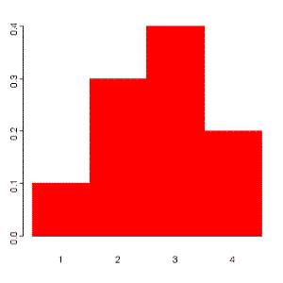

**Continuous**

A continuous random variable is one which takes an infinite number of possible values. Continuous random variables are usually measurements. Examples include height, weight, the amount of sugar in an orange, the time required to run a mile.

A continuous random variable is not defined at specific values. Instead, it is defined over an interval of values, and is represented by the area under a curve (in advanced mathematics, this is known as an integral). The probability of observing any single value is equal to 0, since the number of values which may be assumed by the random variable is infinite.

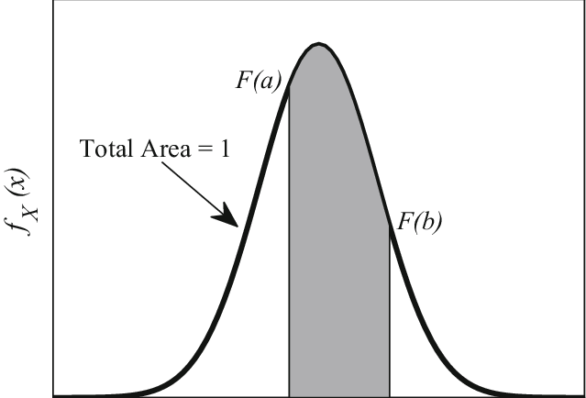Suppose a random variable X may take all values over an interval of real numbers. Then the probability that X is in the set of outcomes A, P(A), is defined to be the area above A and under a curve. The curve, which represents a function p(x), must satisfy the following:

1: The curve has no negative values (p(x) > 0 for all x)

2: The total area under the curve is equal to 1.

## Probability Distribution Function

A probability distribution can be described in various forms, such as by a probability density function or a cumulative distribution function. Probability density functions, or PDFs, are mathematical functions that usually apply to continuous and discrete values. Now that we have a basic idea of what a PDF is, how are they used in statistics? More importantly, how are they applied to Data Science, and what do they look like on paper?

PDFs are very commonly used in statistical analysis, and thus are quite commonly used for Data Science. Generally, PDFs are a necessary tool when studying data with applied science using statistics

The normal distribution, that is quite commonly used in machine-learning. Standard scaling of data is quite a popular way to normalize continuous values whose data has high variance. This PDF transforms continuous samples into standard deviations from the population’s mean.

Looking at a PDF, we see that it has a parabolic curve, where the center is where most of our data lies:

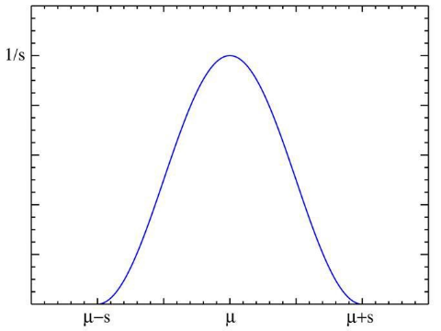

The normal distribution is a great example of a PDF. This is partially because it is very commonly used and familiar to most Scientists, but also partially because it has prominent applications across the entire spectrum of applied statistics. For many of the other distributions, the normal distribution acts as a base to be built upon for probability theory.

## Cumulative Distribution Function

All random variables (**discrete and continuous**) have a cumulative distribution function. It is a function giving the probability that the random variable X is less than or equal to x, for every value x. For a discrete random variable, the cumulative distribution function is found by summing up the probabilities

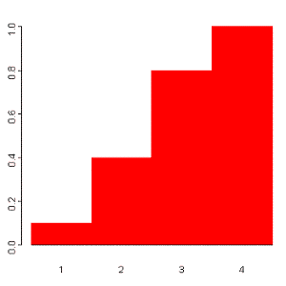The cumulative distribution function for the above probability distribution is calculated as follows:

The probability that X is less than or equal to 1 is 0.1,

the probability that X is less than or equal to 2 is 0.1+0.3 = 0.4,

the probability that X is less than or equal to 3 is 0.1+0.3+0.4 = 0.8, and

the probability that X is less than or equal to 4 is 0.1+0.3+0.4+0.2 = 1.

The probability histogram for the cumulative distribution of this random variable is shown to the right:

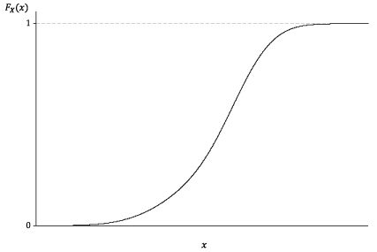

**Comparison between data and CDF**

Let’s work with the ‘Education’ column from our dataset and compare it with the probability density function and cumulative density function.

First, prepare the data and the normal theorical data

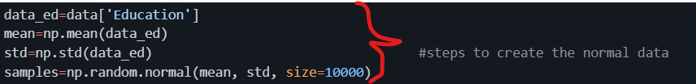

Second, define a function to compute the CDF for one-dimensional data

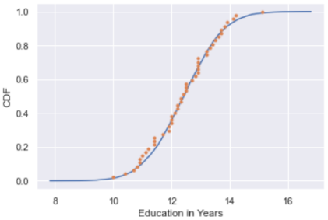And the last step is plot everything together to check normality thru cumulative density function

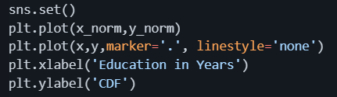

As we can see, our data has similar shape to the cumulative distribution function. Thanks to this we can say that the education column its nearly normally distributed.

## Central Limit Theorem

In probability theory, the central limit theorem (CLT) states that the distribution of a sample variable approximates a normal distribution (i.e., a “bell curve”) as the sample size becomes larger, assuming that all samples are identical in size, and regardless of the population's actual distribution shape.

Put another way, CLT is a statistical premise that, given a sufficiently large sample size from a population with a finite level of variance**, the mean of all sampled variables from the same population will be approximately equal to the mean of the whole population**. Furthermore, these samples approximate a normal distribution, with their variances being approximately equal to the variance of the population as the sample size gets larger, according to the law of large numbers.

## Continuous Distributions

1. Normal Distribution (or Gaussian Distribution)

* Gaussian distribution is a continuous probability distribution with symmetrical sides around its center.
* Its mean, median and mode are equal.
* 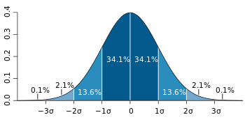Its shape looks like below with most of the data points clustered around the mean with asymptotic tails.

84% of the values drawn from normal distribution lie within 1𝜎

99.7% of the values drawn from normal distribution lie within 3𝜎

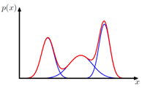

Simple Gaussian distribution fails to capture the following structure 🡪

1. Poisson Distribution

Poisson Distributions are commonly used to find the probability that an event might happen or not knowing how often it usually occurs. Additionally, Poisson Distributions can also be used to predict how many times an event might occur in a given time period.

Poisson Distributions are for example frequently used by insurance companies to conduct risk analysis (eg. predict the number of car crash accidents within a predefined time span) to decide car insurance pricing.

When working with Poisson Distributions, we can be confident of the average time between the occurrence of different events, but the precise moment an event might take place is randomly spaced in time.

The main characteristics which describe Poisson Processes are:

The events are independent of each other (if an event happens, this does not alter the probability that another event can take place).

* An event can take place any number of times (within the defined time period).
* Two events can’t take place simultaneously.
* The average rate between events occurrence is constant.

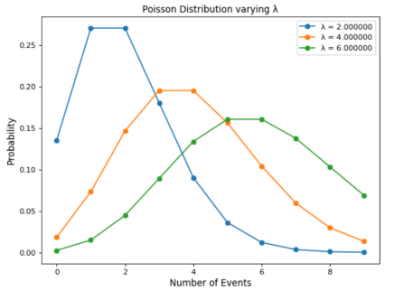Poisson Distribution can be modelled using the following formula, where lambda represents the expected number of events which can take place in a period. Sometimes called the event rate or rate parameter.

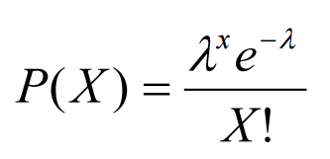

## Skewness

Skewness is the measure of the asymmetry of an ideally symmetric probability distribution and is given by the third standardized moment. If that sounds way too complex, don’t worry! Let me break it down for you.

In simple words, skewness is the measure of how much the probability distribution of a random variable deviates from the normal distribution. Now, you might be thinking – why am I talking about normal distribution here?

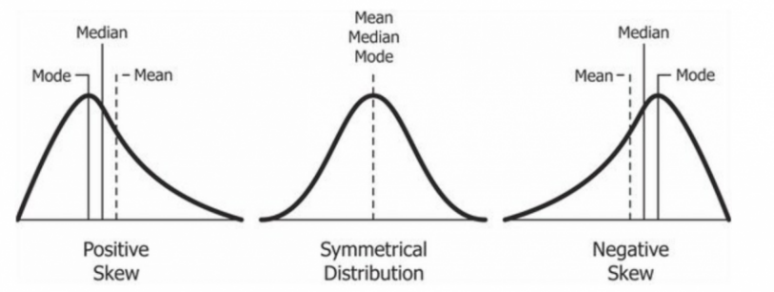Well, the normal distribution is the probability distribution without any skewness. You can look at the image below which shows symmetrical distribution that’s basically a normal distribution and you can see that it is symmetrical on both sides of the dashed line. Apart from this, there are two types of skewness:

* Positive Skewness
* Negative Skewness

Let’s take a look to the following distribution. It is the distribution of horsepower of cars:

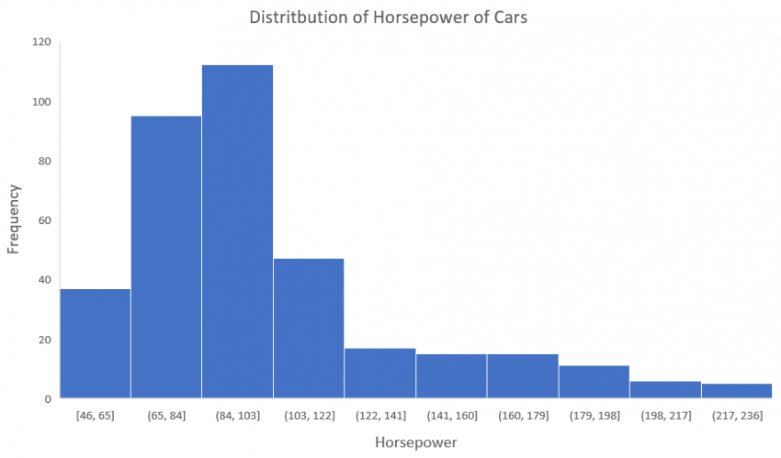You can clearly see that the above distribution is positively skewed. Now, let’s say you want to use this as a feature for the model which will predict the mpg (miles per gallon) of a car.

Since our data is positively skewed here, it means that it has a higher number of data points having low values, i.e., cars with less horsepower. So when we train our model on this data, it will perform better at predicting the mpg of cars with lower horsepower as compared to those with higher horsepower.

Also, skewness tells us about the direction of outliers. You can see that our distribution is positively skewed and most of the outliers are present on the right side of the distribution.

Note: The skewness does not tell us about the number of outliers. It only tells us the direction.

To statistically determine the skewness, we have the Pearson’s coefficient of skewness. This coefficient tells us the direction of the skewness (positive or negative) and we can obtain it in python as follows:

The direction of skewness is given by the sign.

* The coefficient compares the sample distribution with a normal distribution. The larger the value, the larger the distribution differs from a normal distribution.
* A value of zero means no skewness at all.
* A **large negative** value means the distribution is **negatively skewed**.
* A **large positive** value means the distribution is **positively skewed**.

## Monte Carlo Method

Monte Carlo simulation (also called the Monte Carlo Method or Monte Carlo sampling) is a way to account for risk in decision making and quantitative analysis. The method finds all possible outcomes of your decisions and assesses the impact of risk. The technique uses intensive statistical sampling methods that are so complex they are usually only performed with the aid of a computer.

The Monte Carlo method tells you:

* **All of the possible events that could or will happen,**
* **The probability of each possible outcome.**

The Monte Carlo simulation returns a quantified probability, which means that it gives you scenarios with numbers you can use. Let’s say your company wants to know if local bird life will be adversely affected by the construction of a new factory close to wetlands. A quantified probability would be “If we build the factory, there is a 30% chance the nesting bird population will be adversely affected.” This is more useful that a more general, qualified statement like “If we build the factory, the nesting bird population will be affected”.

Monte Carlo simulations are used in many areas of industry and science, including:

* Analyzing radiative heat transfer problems (Wang et.al),
* Estimating the transmission of particles through matter (Biersack & Haggmark),
* Calculating the probability of cost overruns in large projects (McCabe),
* Foreseeing where prices of securities are likely to move (Boyle et. al),
* Analyzing how a network or electric grid will perform in different scenarios. For example, Sortomme et. al ran simulations for how electric vehicle charging will affect the electric drig in the future.
* Assessing risk for credit or insurance (Gordy).
* Simulating proteins in biology (Earl et. al)

Accuracy

While a Monte Carlo simulation provides some good accuracy, it is unlikely to hit the “exact” mark for several reasons:

* Vast amounts of data are usually involved.
* There are usually several unknowns in the system.
* As it is probabilistic (i.e. randomness plays a role in predicting future events), there will always be a margin of error related to the results.

In fact, it can be quite easy to run a “bad” Monte Carlo simulation (Brandimarte, 2014). This can happen for a variety of reasons, including:

* Use of an incorrect model or an unrealistic probability distribution,
* The underlying risk factors aren’t complete (i.e. you haven’t specified them well enough),
* The choice of Monte Carlo (which uses a stochastic model) isn’t suited to your data,
* The random number generator chosen for the method isn’t good enough,
* Computer bugs, which you may not be aware of if your area of expertise is statistics (as opposed to programming)

## Hypothesis Testing

First, you might need to know what is an hypothesis, well, a hypothesis is an educated guess about something in the world around you. It should be testable, either by experiment or observation. For example:

* A new medicine you think might work.
* A way of teaching you think might be better.
* A possible location of new species.
* A fairer way to administer standardized tests.

It can really be anything at all as long as you can put it to the test.

If you are going to propose a hypothesis, it’s customary to write a statement. Your statement will look like this:

**“If I…(do this to an independent variable)….then (this will happen to the dependent variable).”**

For example:

* If I (decrease the amount of water given to herbs) then (the herbs will increase in size).
* If I (give patients counseling in addition to medication) then (their overall depression scale will decrease).

A good hypothesis statement should:

* Include an “if” and “then” statement (according to the University of California).
* Include both the independent and dependent variables.
* Be testable by experiment, survey or other scientifically sound technique.
* Be based on information in prior research (either yours or someone else’s).
* Have design criteria (for engineering or programming projects).

**What is Hypothesis Testing?**

Hypothesis testing in statistics is a way for you to test the results of a survey or experiment to see if you have meaningful results. You’re basically testing whether your results are valid by figuring out the odds that your results have happened by chance. If your results may have happened by chance, the experiment won’t be repeatable and so has little use.

Hypothesis testing can be one of the most confusing aspects for students, mostly because before you can even perform a test, you must know what your null hypothesis is. Often, those tricky word problems that you are faced with can be difficult to decipher. But it’s easier than you think; all you need to do is:

1. Figure out your null hypothesis,
2. State your null hypothesis,
3. Choose what kind of test you need to perform,
4. Either support or reject the null hypothesis.

What is the Null Hypothesis?

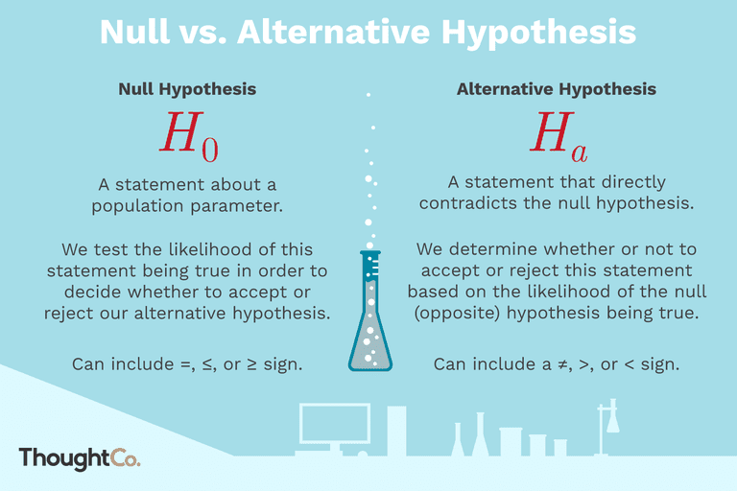If you trace back the history of science, the null hypothesis is always the accepted fact. Simple examples of null hypotheses that are generally accepted as being true are:

* DNA is shaped like a double helix.
* There are 8 planets in the solar system (excluding Pluto).
* Taking Vioxx can increase your risk of heart problems (a drug now taken off the market).

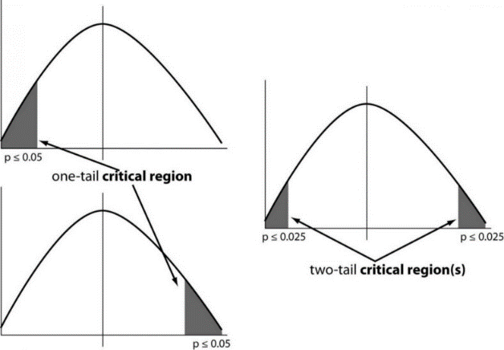The null hypothesis is the default claim, premise, value or parameter that is generally accepted. The alternative hypothesis is a research or investigative hypothesis that includes the claim to be tested which could hopefully replace the null hypothesis, in case it is proved to be true. The various tests below help to figure out to what extent information from the sample data can be extrapolated to the population from which it was drawn.

**One tailed test:** A test of a statistical hypothesis, where the region of rejection is on only one side of the sampling distribution, is called a one-tailed test.

Example: a college has ≥ 4000 student or data science ≤ 80% org adopted.

**Two-tailed test:** A two-tailed test is a statistical test in which the critical area of a distribution is two-sided and tests whether a sample is greater than or less than a certain range of values. If the sample being tested falls into either of the critical areas, the alternative hypothesis is accepted instead of the null hypothesis.

Example: a college != 4000 student or data science != 80% org adopted

P-Value

The P value, or calculated probability, is the probability of finding the observed, or more extreme, results when the null hypothesis (H 0) of a study question is true — the definition of ‘extreme’ depends on how the hypothesis is being tested.

If your P value is less than the chosen significance level, then you reject the null hypothesis i.e. accept that your sample gives reasonable evidence to support the alternative hypothesis. It does NOT imply a “meaningful” or “important” difference; that is for you to decide when considering the real-world relevance of your result.

## Normality Tests

This section lists statistical tests that you can use to check if your data has a Gaussian distribution.

* Shapiro-Wilk Test: **You use it when you want to tell if a random sample comes from a normal distribution or not.** The smaller the W value returned by the test, the more confident you can be that the sample is not normally distributed. This result can lead to the rejection of the null hypothesis you started with in the first place. You can also think about this in terms of a p-value: when it is less than or equal to a certain threshold (usually 0.05), then you can reject the null hypothesis.

* D’Agostino’s K^2 Test: It first computes the skewness and kurtosis to quantify how far the distribution is from Gaussian in terms of asymmetry and shape. It then calculates how far each of these values differs from the value expected with a Gaussian distribution and computes a single P value from the sum of these discrepancies. It is a versatile and powerful normality test, and is recommended.

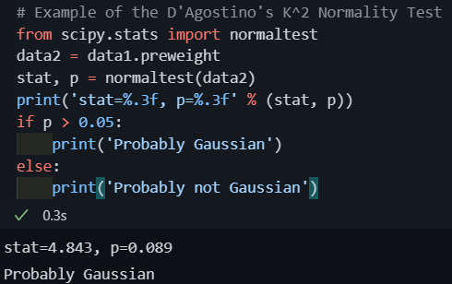

* Anderson-Darling Test: It computes the P value by comparing the cumulative distribution of your data set against the ideal cumulative distribution of a Gaussian distribution. It takes into account the discrepancies at all parts of the cumulative distribution curve

## Correlation Tests

Correlation is a bivariate analysis that measures the strength of association between two variables and the direction of the relationship. In terms of the strength of relationship, the value of the correlation coefficient varies between +1 and -1. A value of ± 1 indicates a perfect degree of association between the two variables. As the correlation coefficient value goes towards 0, the relationship between the two variables will be weaker. The direction of the relationship is indicated by the sign of the coefficient; a + sign indicates a positive relationship and a – sign indicates a negative relationship

* Pearson’s Correlation Coefficient: Pearson r correlation is the most widely used correlation statistic to measure the degree of the relationship between linearly related variables (Is there a relationship between temperature, measured in degrees Fahrenheit, and ice cream sales, measured by income?)
  + Observations in each sample are independent and identically distributed (iid).
  + Observations in each sample are normally distributed.
  + Observations in each sample have the same variance

* Spearman’s Rank Correlation: Spearman rank correlation is a non-parametric test that is used to measure the degree of association between two variables. The Spearman **rank correlation** test does not carry any assumptions about the distribution of the data and is the appropriate correlation analysis when the variables are measured on a scale that is at least ordinal. (Is there a statistically significant relationship between participants’ level of education (high school, bachelor’s, or graduate degree) and their starting salary?)
  + Observations in each sample are independent and identically distributed (iid).
  + Observations in each sample can be ranked.

* Kendall’s Rank Correlation: Kendall rank correlation is a non-parametric test that measures the strength of dependence between two variables. If we consider two samples, a and b, where each sample size is n, we know that the total number of pairings with a b is n(n-1)/2.
  + Observations in each sample are independent and identically distributed (iid).
  + Observations in each sample can be ranked.

* Chi-Squared Test: The test is applied when you have **two categorical variables** from a single population. It is used to determine **whether** **there is a significant association between the two variables**. his is useful when dealing with categorical variables, to see how likely it would be to observe your data’s distribution if those variables were independent. For instance, let’s say you want to know if being a man or a woman makes you more or less likely to be a smoker. If those two variables were independent, you could expect the same percentage of men and women among both smokers and non-smokers. Pearson’s chi-squared test will tell you how confident you can be that there is such a difference, or not

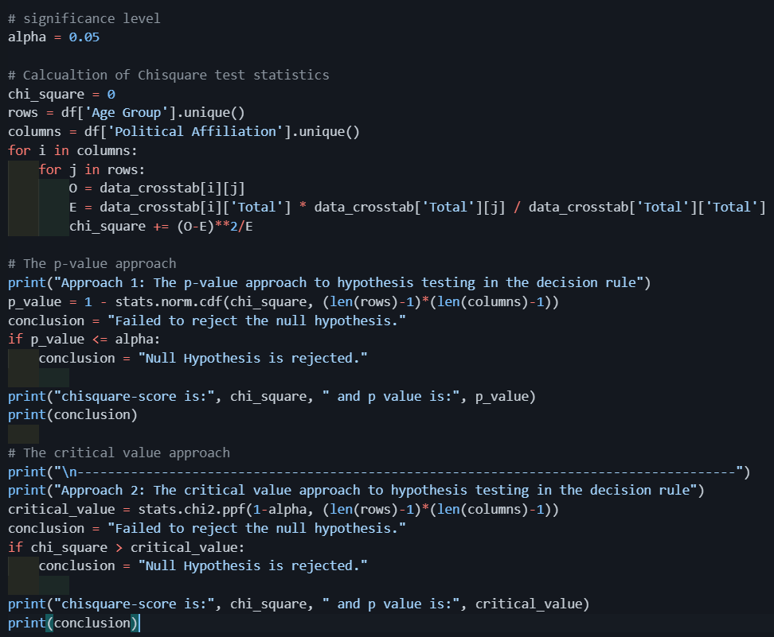

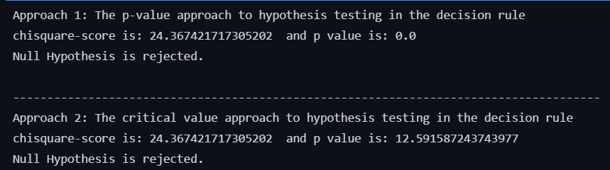

## Stationary Tests

Stationarity is an important concept in time series analysis because this means that the statistical properties of a time series (or rather the process generating it) do not change over time. Stationarity is important because many useful analytical tools and statistical tests and models rely on it. **Time series are stationary if they do not have trend or seasonal effects**

One way to detecting stationarity in time series data is using statistical tests developed to detect specific types of stationarity, namely those brought about by simple parametric models of the generating stochastic process

* Augmented Dickey-Fuller: Tests whether a time series has a unit root, e.g. has a trend or more generally is autoregressive.
  + Observations in are temporally ordered

* Kwiatkowski-Phillips-Schmidt-Shin: **Tests whether a time series is trend stationary or not.**
  + Observations in are temporally ordered

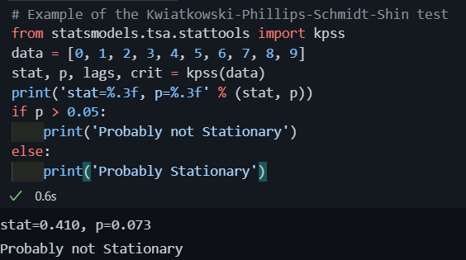

## Parametric Statistical Hypothesis Tests

* Parametric tests can provide trustworthy results with distributions that are skewed and nonnormal
* Parametric tests can provide trustworthy results when the groups have different amounts of variability
* Parametric tests have greater statistical power

* If the mean is a better measure and you have a sufficiently large sample size, a parametric test usually is the better, more powerful choice than the nonparametric

Types of tests:

* Student’s t-test: It is essentially, testing the significance of the difference of the mean values when the sample size is small (i.e, less than 30) and when the population standard deviation is not available.
  + Population distribution is normal, and
  + Samples are random and independent
  + The sample size is small.
  + Population standard deviation is not known.
  + A T-test can be a:
    - One Sample T-test: To compare a sample mean with that of the population mean.
    - Two-Sample T-test: To compare the means of two different samples.

* F-Test: It is a test for the null hypothesis that two normal populations have the same variance.
  + An F-test is regarded as a comparison of equality of sample variances.
  + F-statistic is simply a ratio of two variances.
  + By changing the variance in the ratio, F-test has become a very flexible test. It can then be used to:
    - Test the overall significance for a regression model.
    - To compare the fits of different models and
    - To test the equality of means.
  + Population distribution is normal, and samples are drawn randomly and independently.
* Analysis of Variance Test (ANOVA): Next chapter
* Repeated Measures ANOVA Test: Next chapter

## Nonparametric Statistical Hypothesis Tests

**Nonparametric tests assess the median which can be better for some study areas.** Nonparametric analyses provide an advantage because they assess the median rather than the mean. The mean is not always the better measure of central tendency for a sample. Even though you can perform a valid parametric analysis on skewed data, that doesn’t necessarily equate to being the better method.

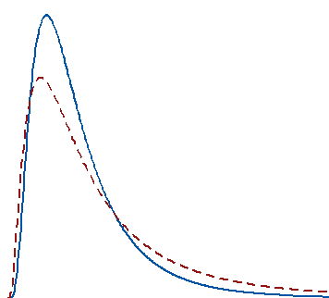Example: Salaries tend to be a right-skewed distribution. The majority of wages cluster around the median, which is the point where half are above, and half are below. However, there is a long tail that stretches into the higher salary ranges. This long tail pulls the mean far away from the central median value. The two distributions are typical for salary distributions.

In these distributions, if several very high-income individuals join the sample, the mean increases by a significant amount even though incomes for most people don’t change. They still cluster around the median.

In this situation, parametric and nonparametric test results can give you different results, and they both can be correct! For the two distributions, if you draw a large random sample from each population, the difference between the means is statistically significant. Despite this, the difference between the medians is not statistically significant. Here’s how this works.

For skewed distributions, changes in the tail affect the mean substantially. Parametric tests can detect this mean change. Conversely, the median is relatively unaffected, and a nonparametric analysis can legitimately indicate that the median has not changed significantly.

**You need to decide whether the mean or median is best for your study and which type of difference is more important to detect.**

**Nonparametric tests are valid when our sample size is small, and your data are potentially nonnormal.** Use a nonparametric test when your sample size isn’t large enough to satisfy the requirements in the table above and you’re not sure that your data follow the normal distribution. With small sample sizes, be aware that normality tests can have insufficient power to produce useful results.

This situation is difficult. Nonparametric analyses tend to have lower power at the outset, and a small sample size only exacerbates that problem.

**Nonparametric tests can analyze ordinal data, ranked data, and outliers**

**If the median is a better measure, consider a nonparametric test regardless of your sample size.**

Types of tests:

* Mann-Whitney U Test: This is also called the Mann-Whitney U test in statistics. This test becomes useful when you want to **look at the difference between two independent groups,** especially when the dependent variable is either ordinal or continuous, but not normally distributed.
  + Observations in each sample are independent and identically distributed (iid).
  + Observations in each sample can be ranked.

* Wilcoxon Signed-Rank Test:
  + Wilcoxon signed-rank test does not assume normality in the data, it can be used when this assumption has been violated and the use of the dependent t-test is inappropriate. It is used to compare two sets of scores that come from the same participants. This can occur when we wish to investigate any change in scores from one time point to another, or when individuals are subjected to more than one condition.
  + For example, you could use a Wilcoxon signed-rank test to understand whether there was a difference in smokers' daily cigarette consumption before and after a 6 week hypnotherapy programme (i.e., your dependent variable would be "daily cigarette consumption", and your two related groups would be the cigarette consumption values "before" and "after" the hypnotherapy programme).
  + Also use a Wilcoxon signed-rank test to understand whether there was a difference in reaction times under two different lighting conditions (i.e., your dependent variable would be "reaction time", measured in milliseconds, and your two related groups would be reaction times in a room using "blue light" versus "red light").
  + Observations in each sample are independent and identically distributed (iid).
  + Observations in each sample can be ranked.
  + Observations across each sample are paired.

* Kruskal-Wallis H Test:
  + This test is used for comparing two or more independent samples of equal or different sample sizes.

It extends the Mann-Whitney-U-Test which is used to comparing only two groups.

* + One-Way ANOVA is the parametric equivalent of this test. And that’s why it is also known as ‘One-Way ANOVA on ranks.
  + It uses ranks instead of actual data.
  + It does not assume the population to be normally distributed.
  + The test statistic used here is “H”.

* Friedman Test
  + The Friedman test is the non-parametric alternative to the one-way ANOVA with repeated measures. It is used to test for differences between groups when the dependent variable being measured is ordinal. It can also be used for continuous data that has violated the assumptions necessary to run the one-way ANOVA with repeated measures (e.g., data that has marked deviations from normality).
  + Observations in each sample are independent and identically distributed (iid).
  + Observations in each sample can be ranked.
  + Observations across each sample are paired.

## Analysis of Variance (ANOVA)

An ANOVA test is a way to find out if survey or experiment results are significant. In other words, they help you to figure out if you need to reject the null hypothesis or accept the alternate hypothesis.

**Basically, you’re testing groups to see if there’s a difference between them**. Examples of when you might want to test different groups:

* A group of psychiatric patients are trying three different therapies: counseling, medication and biofeedback. You want to see if one therapy is better than the others.
* A manufacturer has two different processes to make light bulbs. They want to know if one process is better than the other.
* Students from different colleges take the same exam. You want to see if one college outperforms the other.

There are two different types of independent variables to perform an ANOVA, which are:

* One-way has one independent variable (with 2 levels). For example: brand of cereal,
* Two-way has two independent variables (it can have multiple levels). For example: brand of cereal, calories.

Groups or levels are different groups within the same independent variable. In the above example, your levels for “brand of cereal” might be Lucky Charms, Raisin Bran, Cornflakes — a total of three levels. Your levels for “Calories” might be: sweetened, unsweetened — a total of two levels.

Let’s say you are studying if an alcoholic support group and individual counseling combined is the most effective treatment for lowering alcohol consumption. You might split the study participants into three groups or levels: Medication only, Medication and counseling, Counseling only. Your dependent variable would be the number of alcoholic beverages consumed per day.

*If your groups or levels have a hierarchical structure (each level has unique subgroups), then use a nested ANOVA for the analysis.*

**One Way ANOVA**

A one-way ANOVA is used to compare two means from two independent (unrelated) groups using the F-distribution. The null hypothesis for the test is that the two means are equal. Therefore, a significant result means that the two means are unequal.

Examples of when to use a one-way ANOVA

Situation 1: You have a group of individuals randomly split into smaller groups and completing different tasks. For example, you might be studying the effects of tea on weight loss and form three groups: green tea, black tea, and no tea.

Situation 2: Similar to situation 1, but in this case the individuals are split into groups based on an attribute they possess. For example, you might be studying leg strength of people according to weight. You could split participants into weight categories (obese, overweight and normal) and measure their leg strength on a weight machine.

Example in Python

For this new data we have a column named Diet which tells us the different types of diets assigned to a person. We have 3 different values 🡪

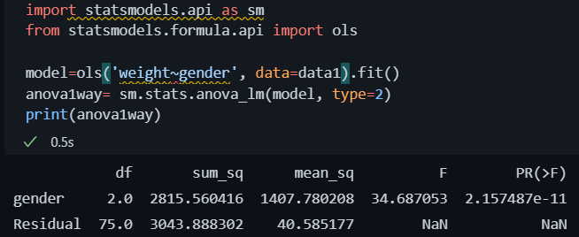Now let’s perform an ANOVA test comparing gender and pre weight 🡪

The p-value (2,16*e -11) for gender is much lower than the level of significance (0.05), therefore, we can say that there’s an association between the gender and the pre weight.

**Two Way ANOVA**

A Two-Way ANOVA is an extension of the One Way ANOVA. With a One Way, you have one independent variable affecting a dependent variable. With a Two-Way ANOVA, there are two independents. Use a two-way ANOVA when you have one measurement variable (i.e. a quantitative variable) and two nominal variables. In other words, **if your experiment has a quantitative outcome and you have two categorical explanatory variables**, a two-way ANOVA is appropriate.

For example, you might want to find out if there is an interaction between income and gender for anxiety level at job interviews. The anxiety level is the outcome, or the variable that can be measured. Gender and Income are the two categorical variables. These categorical variables are also the independent variables, which are called factors in a Two Way ANOVA.

Two-way example

For this example, we’ll use the same dataset as the one-way analysis.

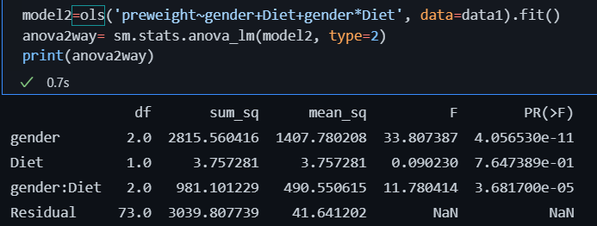As we can see the p-value for gender is much lowe than the level of significance but the p-value for Diet is higher. Therefore, there is no association between the pre weight and the diet but there are an association between pre weight and gender.

We have one last value which is the interaction between gender and Diet and their p value is lower than the level of significance. The interaction between them is statistically significant.

**MANOVA**

MANOVA is just an ANOVA with several dependent variables. It’s similar to many other tests and experiments in that it’s purpose is to find out if the response variable (i.e. your dependent variable) is changed by manipulating the independent variable. The test helps to answer many research questions, including:

Do changes to the independent variables have statistically significant effects on dependent variables?

What are the interactions among dependent variables?

What are the interactions among independent variables?

MANOVA Example

Suppose you wanted to find out if a difference in textbooks affected students’ scores in math and science. Improvements in math and science means that there are two dependent variables, so a MANOVA is appropriate.

An ANOVA will give you a single (univariate) f-value while a MANOVA will give you a multivariate F value. MANOVA tests the multiple dependent variables by creating new, artificial, dependent variables that maximize group differences. These new dependent variables are linear combinations of the measured dependent variables.

Interpreting the MANOVA results

If the multivariate F value indicates the test is statistically significant, this means that something is significant. In the above example, you would not know if math scores have improved, science scores have improved (or both). Once you have a significant result, you would then have to look at each individual component (the univariate F tests) to see which dependent variable(s) contributed to the statistically significant result.

Advantages

MANOVA enables you to test multiple dependent variables.

MANOVA can protect against Type I errors.

Disadvantages

MANOVA is many times more complicated than ANOVA, making it a challenge to see which independent variables are affecting dependent variables.

One degree of freedom is lost with the addition of each new variable.

The dependent variables should be uncorrelated as much as possible. If they are correlated, the loss in degrees of freedom means that there isn’t much advantages in including more than one dependent variable on the test.

**Nested ANOVA**

A nested ANOVA (also called a hierarchical ANOVA) is an extension of a simple ANOVA for experiments where each group is divided into two or more random subgroups. It tests to see if there is variation between groups, or within nested subgroups of the attribute variable. You should use nested ANOVA when you have:

* One measurement variable,
* Two or more nested nominal variables (factors).

Example

Let’s say you wanted to investigate the wage gap between men and women. You also think that height affects wages (which is true — see The Atlantic’s story on Why Tall People Make More) as does obesity (also true: see Forbes’ story The Price of Obesity). Your factors or levels (sex, height, weight) are nested within each other. For example, “weight” is not a standalone factor — it’s nested under male/female. The following image shows the hierarchical model:

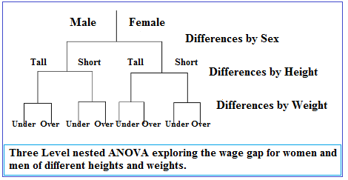

## Estimation

The process of extrapolating information regarding the population from a sample is called Estimation. As it’s impossible to collect information from every single member of the population we instead gather information from a sample and work our way to estimate the information about the population. And in this process, we use something called an “Estimator” to generate the estimation.

When a value is calculated for the entire population, it’s called a parameter and the corresponding term for a subset of the population also known as the sample is called a statistic.

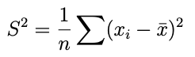**Is my estimator biased or unbiased?**

Variance is a commonly used estimator which is used to determine the spread in the data usually given by the following formula:

But this formula of variance tends to underestimate the value of variance when we move to a larger sample (or population). In other words, it tends to be biased. Bias is nothing but the difference between the expected value and actual value. When this bias equals 0 we say that the estimator is unbiased. The above formula yields a non-zero bias

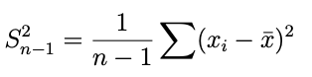

This formula yields a bias that is equal to zero. It also doesn’t underestimate population variance. Intuitively, since the denominator is a smaller number now, the value of variance is larger, and hence for a larger sample (or the population), we naturally expect a larger variance.

The sample mean is always an unbiased estimator of the population mean. That is because the expected value of mean equals the actual value or true mean of the population. Some samples might have a larger mean than the population mean and some might have a sample mean lower than the population mean. However, when this process is repeated over many iterations and the average of the estimates is calculated over these iterations, the mean of these sampling experiments will eventually equal the population mean

**How do we determine the best estimator?**

That really depends on whether we are trying to minimize the error or maximize the chance of getting the right answer.

If we are trying to minimize the error, we use something called Mean Squared Error or Root Mean Squared Error. In a real experiment, the process of calculating the estimator is iterated many times over numerous different samples. In the absence of an outlier, the sample mean, ‘xbar’, minimizes the Mean Squared Error (MSE) :

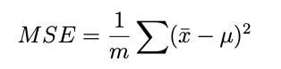

where ‘m’ is the number of iterations. RMSE is nothing but the Square root of MSE.

## Confidence intervals

As it sounds, the confidence interval **is a range of values**. In the ideal condition, it should contain the best estimate of a statistical parameter. It is expressed as a percentage. 95% confidence interval is the most common. You can use other values like 97%, 90%, 75%, or even 99% confidence interval if your research demands. Let’s understand it by an example:

Here is a statement:

“In a sample of 659 parents with toddlers, about 85%, stated they use a car seat for all travel with their toddler. From these results, a 95% confidence interval was provided, going from about 82.3% up to 87.7%.”

This statement means, we are 95% certain that the population proportion who use a car seat for all travel with their toddler will fall between 82.3% and 87.7%. If we take a different sample or a subsample of these 659 people, 95% of the time, the percentage of the population who use a car seat in all travel with their toddlers will be in between 82.3% and 87.7%.

*Remember, 95% confidence interval does not mean 95% probability*

The conditions to calculate a valid confidence interval for a proportion are the following:

* **The sample must be random.**
* A normal distribution can approximate the sampling distribution of the sample proportions. The rule of thumb is that you need to have at least 10 successes and 10 failures.
* The samples are required to be independent. The rule of thumb is that if you are sampling without replacement, your sample size should be less than 10% of the population size.
* **But if the sample size is large enough (30 or more) normal distribution is not necessary.**

**How to Calculate the Confidence Interval**

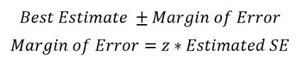The calculation of the confidence interval involves the best estimate which is obtained by the sample and a margin of error. So, we take the best estimate and add a margin of error to it. Here is the formula for the confidence interval and the margin of error🡪

Combining these two formulas above, we can elaborate the **formula for CI** as follows:

Population proportion or the mean is calculated from the sample. In the example of “the parents with toddlers”, the best estimate or the population proportion of parents that uses car seats in all travel with their toddlers is 85%. So, the best estimate (population proportion) is 85. z-score is fixed for the confidence level (CL).

A z-score for a 95% confidence interval for a large enough sample size(30 or more) is 1.96.

Here are the z-scores for some commonly used confidence levels:

The method to calculate the standard error is different for population proportion and mean. The formula to calculate standard error of population proportion is:

The formula to calculate the standard error of the sample mean is:

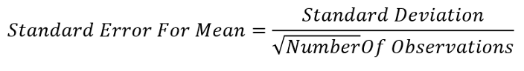

**Confidence interval in Python**

We are going to construct a CI for the female population proportion that has heart disease. We do not need all the columns in the dataset. We will only use the ‘target’ column as that contains if a person has heart disease or not and the Sex1 column we just created. Make a DataFrame with only these two columns and drop all the null values

We need the number of females who have heart disease. The line of code below will give the number of males and females with heart disease and with no heart disease.

Now let’s calculate the confident intervals

**CI for the Difference in Population Proportion**

Is the population proportion of females with heart disease the same as the population proportion of males with heart disease? If they are the same, then the difference in both the population proportions will be zero.

We will calculate a confidence interval of the difference in the population proportion of females and males with heart disease.

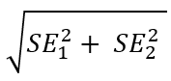Calculate the male population proportion with heart disease and standard error using the same procedure. I’m going to jump all the steps and show you the standard error for the male population which is 0.034. Now calculate the difference in standard error. 🡪

Let’s use this formula to calculate the difference in the standard error of male and female population with heart disease and then use this standard error to **calculate the difference in the population proportion of males and females with heart disease** and construct the CI of the difference.

The CI is 0.18 and 0.4. This range does not have 0 in it. Both the numbers are above zero. So, We cannot make any conclusion that the population proportion of females with heart disease is the same as the population proportion of males with heart disease. If the CI would be -0.12 and 0.1, we could say that the male and female population proportion with heart disease is the same.

If you want to learn more about confidence interval you can look to the calculation of CI of mean or the calculation of CI of The Difference in Mean.

## Maximum Likelihood Estimation (MLE)

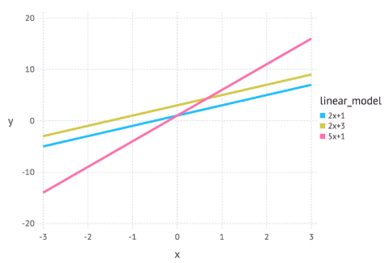Often in machine learning we use a model to describe the process that results in the data that are observed. For example, we may use a random forest model to classify whether customers may cancel a subscription from a service (known as churn modelling) or we may use a linear model to predict the revenue that will be generated for a company depending on how much they may spend on advertising (this would be an example of linear regression). Each model contains its own set of parameters that ultimately defines what the model looks like.

For a linear model we can write this as y = mx + c. In this example x could represent the advertising spend and y might be the revenue generated. m and c are parameters for this model. Different values for these parameters will give different lines (see the next figure).

Maximum likelihood estimation is a method that determines values for the parameters of a model. The parameter values are found such that they maximize the likelihood that the process described by the model produced the data that were actually observed.

The above definition may still sound a little cryptic so let’s go through an example to help understand this.

Let’s suppose we have observed 10 data points from some process. For example, each data point could represent the length of time in seconds that it takes a student to answer a specific exam question. These 10 data points are shown in the figure below

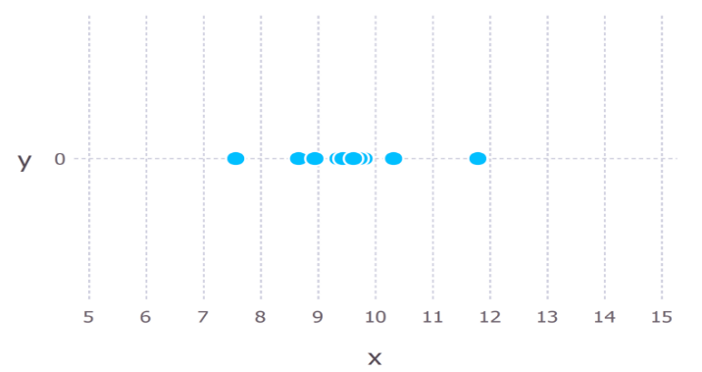

We first have to decide which model we think best describes the process of generating the data. This part is very important. At the very least, we should have a good idea about which model to use. This usually comes from having some domain expertise but we wont discuss this here.

For these data we’ll assume that the data generation process can be adequately described by a Gaussian (normal) distribution. Visual inspection of the figure above suggests that a Gaussian distribution is plausible because most of the 10 points are clustered in the middle with few points scattered to the left and the right. (Making this sort of decision on the fly with only 10 data points is ill-advised but given that I generated these data points we’ll go with it).

Recall that the Gaussian distribution has 2 parameters. The mean, μ, and the standard deviation, σ. Different values of these parameters result in different curves (just like with the straight lines above). We want to know which curve was most likely responsible for creating the data points that we observed? (See figure below). **Maximum likelihood estimation is a method that will find the values of μ and σ that result in the curve that best fits the data. For which parameter value does the observed data have the biggest probability?**

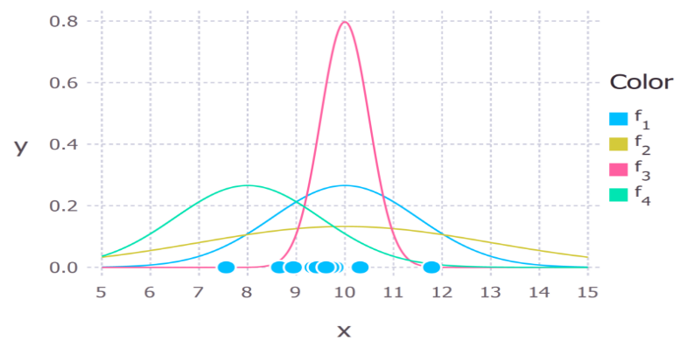

The true distribution from which the data were generated was f1 ~ N(10, 2.25), which is the blue curve in the figure above.

Example

Regression on Normally Distributed Data

Here, we perform simple linear regression on synthetic data. The data is ensured to be normally distributed by incorporating some random Gaussian noises. Data can be said to be normally distributed if its residual follows the normal distribution.

Generate some synthetic data based on the assumption of Normal Distribution.

Visualize the synthetic data on Seaborn’s regression plot.

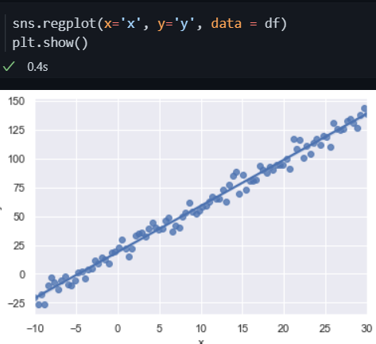

The data is normally distributed, and the output variable is a continuously varying number. Hence, we can use the Ordinary Least Squares (OLS) method to determine the model parameters and use them as a benchmark to evaluate the Maximum Likelihood Estimation approach. Apply the OLS algorithm to the synthetic data and find the model parameters

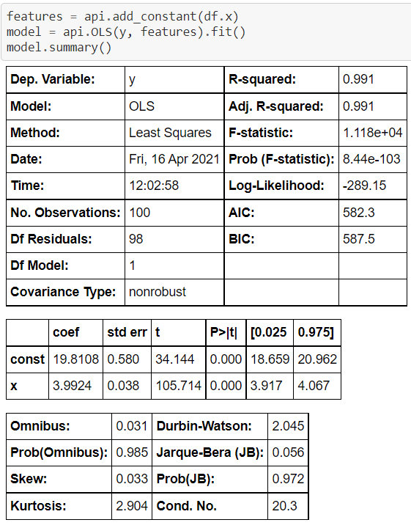

We get the intercept and regression coefficient values of the simple linear regression model. Further, we can derive the standard deviation of the normal distribution with the following codes.

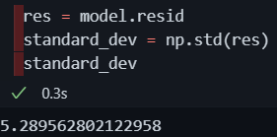

As we have solved the simple linear regression problem with an OLS model, it is time to solve the same problem by formulating it with Maximum Likelihood Estimation.

Define a user-defined Python function that can be iteratively called to determine the negative log-likelihood value. The key idea of formulating this function is that it must contain two elements: the first is the model building equation (here, the simple linear regression). The second is the logarithmic value of the probability density function (here, the log PDF of normal distribution). Since we need negative log-likelihood, it is obtained just by negating the log-likelihood.

Minimize the negative log-likelihood of the generated data using the minimize method available with SciPy’s optimize module.

The MLE approach arrives at the final optimal solution after 35 iterations. The model’s parameters, the intercept, the regression coefficient and the standard deviation are well matching to those obtained using the OLS approach.

Here comes the big question. If the OLS approach provides the same results without any tedious function formulation, why do we go for the MLE approach? The answer is that the OLS approach is completely problem-specific and data-oriented. It cannot be used for a different kind of problem or a different data distribution. On **the other hand, the MLE approach is a general template for any kind of problem**. With expertise in Maximum Likelihood Estimation, users can formulate and solve their own machine learning problems with raw data in hand.

## Kernel Density Estimate

Density Estimation¶

Density estimation walks the line between unsupervised learning, feature engineering, and data modeling. Some of the most popular and useful density estimation techniques are mixture models such as Gaussian Mixtures (sklearn.mixture.GaussianMixture), and neighbor-based approaches such as the kernel density estimate (sklearn.neighbors.KernelDensity). Gaussian Mixtures are discussed more fully in the context of clustering, because the technique is also useful as an unsupervised clustering scheme.

Density estimation is a very simple concept, and most people are already familiar with one common density estimation technique: the histogram.

**Kernel Density Estimation**

Kernel density estimation in scikit-learn is implemented in the sklearn.neighbors.KernelDensity estimator, which uses the Ball Tree or KD Tree for efficient queries (see Nearest Neighbors for a discussion of these). Though the above example uses a 1D data set for simplicity, kernel density estimation can be performed in any number of dimensions, though in practice the curse of dimensionality causes its performance to degrade in high dimensions.

The kernel density estimator can be used with any of the valid distance metrics (see sklearn.neighbors.DistanceMetric for a list of available metrics), though the results are properly normalized only for the Euclidean metric. One particularly useful metric is the Haversine distance which measures the angular distance between points on a sphere.

## Regression

What is regression?

Regression analysis is defined in Wikipedia as:

*In statistical modeling, regression analysis is a set of statistical processes for estimating the relationships between a dependent variable (often called the ‘outcome variable’) and one or more independent variables (often called ‘predictors’, ‘covariates’, or ‘features’).*

The terminology you will often listen related to regression analysis is:

* Dependent variable or target variable: Variable to predict.
* Independent variable or predictor variable: Variables to estimate the dependent variable.
* Outlier: Observation that differs significantly from other observations. It should be avoided since it may hamper the result.
* Multicollinearity: Situation in which two or more independent variables are highly linearly related.
* Homoscedasticity or homogeneity of variance: Situation in which the error term is the same across all values of the independent variables.

Regression analysis is primarily used for two distinct purposes. First, it is widely used for prediction and forecasting, which overlaps with the field of machine learning. Second, it is also used to infer causal relationships between independent and dependent variables.

I’m going to explain it deep in the machine learning chapter

## Covariance and Correlation

Covariance and correlation are two key concepts in statistics and probability theory, but what do they actually mean in practice? More importantly, when do we use them?

Put simply: we use both concepts to understand relationships between data variables and values. We can quantify the relationship between variables and then use these learnings to either select, add or alter variables for predictive modeling, insight generation or even storytelling using data. Thus, both correlation and covariance have high utility in machine learning and data analysis.

Put simply, both covariance and correlation measure the relationship and the dependency between two variables. **Covariance indicates the direction of the linear relationship between variables while correlation measures both the strength and direction of the linear relationship between two variables**. Correlation is a function of the covariance.

What sets these two concepts apart is the fact that correlation values are standardized whereas covariance values are not.

**Types of correlations**

* Pearson’s correlation:

* **Spearman’s correlation:**

## Causation

While causation and correlation can exist at the same time, correlation does not imply causation. **Causation explicitly applies to cases where action A causes outcome B.** On the other hand, correlation is simply a relationship. Action A relates to Action B—but one event doesn’t necessarily cause the other event to happen.

Correlation and causation are often confused because the human mind likes to find patterns even when they do not exist. We often fabricate these patterns when two variables appear to be so closely associated that one is dependent on the other. That would imply a cause and effect relationship where the dependent event is the result of an independent event.

However, we cannot simply assume causation even if we see two events happening, seemingly together, before our eyes. One, our observations are purely anecdotal. Two, there are so many other possibilities for an association, including:

* The opposite is true: B actually causes A.
* The two are correlated, but there’s more to it: A and B are correlated, but they’re actually caused by C.
* There’s another variable involved: A does cause B—as long as D happens.
* There is a chain reaction: A causes E, which leads E to cause B (but you only saw that A causes B from your own eyes).

## Distance Measures

1. Euclidean distance

it is a distance measure that best can be explained as the length of a segment connecting two points.

* Disadvantages

Although it is a common distance measure, Euclidean distance is not scale in-variant which means that distances computed might be skewed depending on the units of the features. Typically, one needs to normalize the data before using this distance measure.

Moreover, as the dimensionality increases of your data, the less useful Euclidean distance becomes. This has to do with the curse of dimensionality which relates to the notion that higher-dimensional space does not act as we would, intuitively, expect from 2- or 3-dimensional space. For a good summary, see this post.

* Use Cases

Euclidean distance works great when you have low-dimensional data and the magnitude of the vectors is important to be measured. Methods like kNN and HDBSCAN show great results out of the box if Euclidean distance is used on low-dimensional data.

Although many other measures have been developed to account for the disadvantages of Euclidean distance, it is still one of the most used distance measures for good reasons. It is incredibly intuitive to use, simple to implement and shows great results in many use-cases.

1. Cosine Similarity

Cosine similarity has often been used as a way to counteract Euclidean distance’s problem with high dimensionality. The cosine similarity is simply the cosine of the angle between two vectors. It also has the same inner product of the vectors if they were normalized to both have length one.

Two vectors with exactly the same orientation have a cosine similarity of 1, whereas two vectors diametrically opposed to each other have a similarity of -1. Note that their magnitude is not of importance as this is a measure of orientation.

* Disadvantages

One main disadvantage of cosine similarity is that the magnitude of vectors is not taken into account, merely their direction. In practice, this means that the differences in values are not fully taken into account. If you take a recommender system, for example, then the cosine similarity does not take into account the difference in rating scale between different users.

* Use Cases

We use cosine similarity often when we have high-dimensional data and when the magnitude of the vectors is not of importance. For text analyses, this measure is quite frequently used when the data is represented by word counts. For example, when a word occurs more frequently in one document over another this does not necessarily mean that one document is more related to that word. It could be the case that documents have uneven lengths and the magnitude of the count is of less importance. Then, we can best be using cosine similarity which disregards magnitude

# Machine Learning

## What is Machine Learning?

Machine learning is a branch of artificial intelligence (AI) and computer science which focuses on the use of data and algorithms to imitate the way that humans learn, gradually improving its accuracy.

Machine learning is an important component of the growing field of data science. Through the use of statistical methods, algorithms are trained to make classifications or predictions, uncovering key insights within data mining projects. These insights subsequently drive decision making within applications and businesses, ideally impacting key growth metrics. As big data continues to expand and grow, the market demand for data scientists will increase, requiring them to assist in the identification of the most relevant business questions and subsequently the data to answer them.

UC Berkeley breaks out the learning system of a machine learning algorithm into three main parts.

* A Decision Process: In general, machine learning algorithms are used to make a prediction or classification. Based on some input data, which can be labelled or unlabeled, your algorithm will produce an estimate about a pattern in the data.
* An Error Function: An error function serves to evaluate the prediction of the model. If there are known examples, an error function can make a comparison to assess the accuracy of the model.
* An Model Optimization Process: If the model can fit better to the data points in the training set, then weights are adjusted to reduce the discrepancy between the known example and the model estimate. The algorithm will repeat this evaluate and optimize process, updating weights autonomously until a threshold of accuracy has been met.

## Numerical, Categorical and Ordinal Variables

**Numerical data**

These data have meaning as a measurement, such as a person’s height, weight, IQ, or blood pressure; or they’re a count, such as the number of stock shares a person owns, how many teeth a dog has, or how many pages you can read of your favorite book before you fall asleep. (Statisticians also call numerical data quantitative data.)

Numerical data can be further broken into two types: discrete and continuous.

* Discrete data represent items that can be counted; they take on possible values that can be listed out. The list of possible values may be fixed (also called finite); or it may go from 0, 1, 2, on to infinity (making it countably infinite).For example, the number of heads in 100 coin flips takes on values from 0 through 100 (finite case), but the number of flips needed to get 100 heads takes on values from 100 (the fastest scenario) on up to infinity (if you never get to that 100th heads). Its possible values are listed as 100, 101, 102, 103 . . . (representing the countably infinite case).
* Continuous data represent measurements; their possible values cannot be counted and can only be described using intervals on the real number line. For example, the exact amount of gas purchased at the pump for cars with 20-gallon tanks would be continuous data from 0 gallons to 20 gallons, represented by the interval [0, 20], inclusive. You might pump 8.40 gallons, or 8.41, or 8.414863 gallons, or any possible number from 0 to 20. In this way, continuous data can be thought of as being uncountably infinite. For ease of recordkeeping, statisticians usually pick some point in the number to round off. Another example would be that the lifetime of a C battery can be anywhere from 0 hours to an infinite number of hours (if it lasts forever), technically, with all possible values in between. Granted, you don’t expect a battery to last more than a few hundred hours, but no one can put a cap on how long it can go (remember the Energizer Bunny?).

**Categorical data**

Categorical data represent characteristics such as a person’s gender, marital status, hometown, or the types of movies they like. Categorical data can take on numerical values (such as “1” indicating male and “2” indicating female), but those numbers don’t have mathematical meaning. You couldn’t add them together, for example. (Other names for categorical data are qualitative data, or Yes/No data.)

**Ordinal data**

Ordinal data mixes numerical and categorical data. The data fall into categories, but the numbers placed on the categories have meaning. For example, rating a restaurant on a scale from 0 (lowest) to 4 (highest) stars gives ordinal data.

Ordinal data are often treated as categorical, where the groups are ordered when graphs and charts are made. However, unlike categorical data, the numbers do have mathematical meaning. For example, if you survey 100 people and ask them to rate a restaurant on a scale from 0 to 4, taking the average of the 100 responses will have meaning. This would not be the case with categorical data.

## Supervised Learning

What is supervised learning?

Supervised learning, also known as supervised machine learning, is a subcategory of machine learning and artificial intelligence. It is defined by its **use of labeled datasets to train algorithms that to classify data or predict outcomes accurately**. As input data is fed into the model, it adjusts its weights until the model has been fitted appropriately, which occurs as part of the cross validation process. Supervised learning helps organizations solve for a variety of real-world problems at scale, such as classifying spam in a separate folder from your inbox.

How supervised learning works

Supervised learning uses a training set to teach models to yield the desired output. This training dataset includes inputs and correct outputs, which allow the model to learn over time. The algorithm measures its accuracy through the loss function, adjusting until the error has been sufficiently minimized.

Supervised learning can be separated into two types of problems when data mining—classification and regression:

* **Classification** uses an algorithm to accurately assign test data into specific categories. It recognizes specific entities within the dataset and attempts to draw some conclusions on how those entities should be labeled or defined. Common classification algorithms are linear classifiers, support vector machines (SVM), decision trees, k-nearest neighbor, and random forest, which are described in more detail below.
* **Regression** is used to understand the relationship between dependent and independent variables. It is commonly used to make projections, such as for sales revenue for a given business. Linear regression, logistical regression, and polynomial regression are popular regression algorithms.

## Unsupervised Learning

What is unsupervised learning?

Unsupervised learning, also known as unsupervised machine learning, uses **machine learning algorithms to analyze and cluster unlabeled datasets**. These algorithms **discover hidden patterns or data groupings** without the need for human intervention. Its ability to discover similarities and differences in information make it the ideal solution for exploratory data analysis, cross-selling strategies, customer segmentation, and image recognition.

Common unsupervised learning approaches

Unsupervised learning models are utilized for **three main tasks—clustering, association, and dimensionality reduction**. Below we’ll define each learning method and highlight common algorithms and approaches to conduct them effectively.

* **Clustering**: This is a data mining technique which groups unlabeled data based on their similarities or differences. Clustering algorithms are used to process raw, unclassified data objects into groups represented by structures or patterns in the information. Clustering algorithms can be categorized into a few types, specifically exclusive, overlapping, hierarchical, and probabilistic
* **Association Rules:** An association rule is a rule-based method for finding relationships between variables in a given dataset. These methods are frequently used for market basket analysis, allowing companies to better understand relationships between different products. Understanding consumption habits of customers enables businesses to develop better cross-selling strategies and recommendation engines. Examples of this can be seen in Amazon’s “Customers Who Bought This Item Also Bought” or Spotify’s "Discover Weekly" playlist. While there are a few different algorithms used to generate association rules, such as Apriori, Eclat, and FP-Growth, the Apriori algorithm is most widely used.
* **Dimensionality reduction:** While more data generally yields more accurate results, it can also impact the performance of machine learning algorithms (e.g. overfitting) and it can also make it difficult to visualize datasets. Dimensionality reduction is a technique used when the number of features, or dimensions, in a given dataset is too high. It reduces the number of data inputs to a manageable size while also preserving the integrity of the dataset as much as possible. It is commonly used in the preprocessing data stage, and there are a few different dimensionality reduction methods that can be used, such as:

## Reinforcement Learning

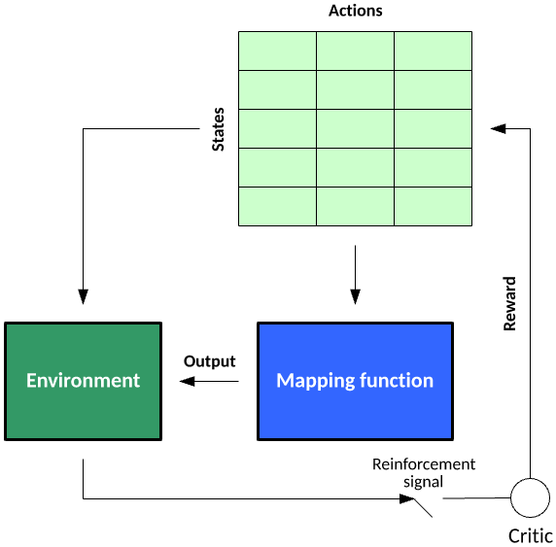Reinforcement learning is an interesting learning model, with the ability not just to learn how to map an input to an output but to map a series of inputs to outputs with dependencies (Markov decision processes, for example). Reinforcement learning exists in the context of states in an environment and the actions possible at a given state. During the learning process, the algorithm randomly explores the state–action pairs within some environment (to build a state–action pair table), then in practice of the learned information exploits the state–action pair rewards to choose the best action for a given state that lead to some goal state

Consider a simple agent that plays blackjack. The states represent the sum of the cards for the player. The actions represent what a blackjack-playing agent may do — in this case, hit or stand. Training an agent to play blackjack would involve many hands of poker, where reward for a given state–action nexus is given for winning or losing. For example, the value for a state of 10 would be 1.0 for hit and 0.0 for stand (indicating that hit is the optimal choice). For state 20, the learned reward would likely be 0.0 for hit and 1.0 for stand. For a less-straightforward hand, a state of 17 may have action values of 0.95 stand and 0.05 hit. This agent would then probabilistically stand 95 percent of the time and hit 5 percent of the time. These rewards would be leaned over many hands of poker, indicating the best choice for a given state (or hand).

## Training and Test Data

To introduce this idea, you can think of dividing your data set into two subsets:

* training set—a subset to train a model.
* test set—a subset to test the trained model.

You could imagine slicing the single data set as follows:

Make sure that your test set meets the following two conditions:

* Is large enough to yield statistically meaningful results.
* Is representative of the data set as a whole. In other words, don't pick a test set with different characteristics than the training set.

Assuming that your test set meets the preceding two conditions, your goal is to create a model that generalizes well to new data. Our test set serves as a proxy for new data. For example, consider the following figure. Notice that the model learned for the training data is very simple. This model doesn't do a perfect job—a few predictions are wrong. However, this model does about as well on the test data as it does on the training data. In other words, this simple model does not overfit the training data.

ADD MORE ALGORITHMS CLASIFICATION, REGRESSIOM CLUSTERING